**Talatam. Ganga Siva Sandhya, M.sc**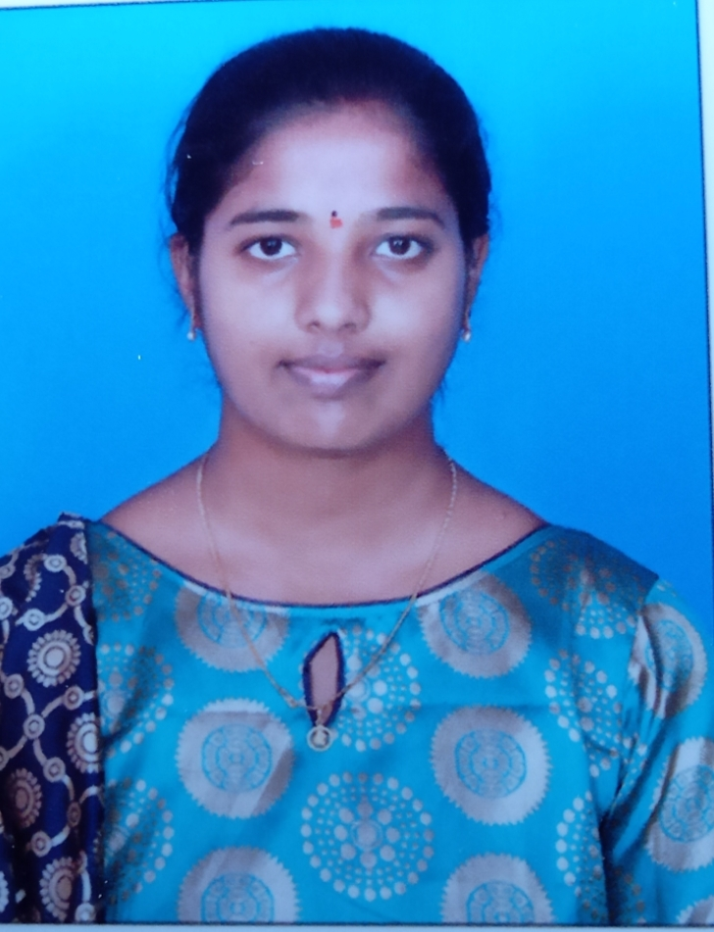

**Lecturer in Mathematics**

**Mobile:** 9346496337

**E-mail:** sandhyatalatam1947@gmail.com

**CAREER OBJECTIVE**

I work for any organization which gives me an opportunity to survive on my own respect. Will put all my efforts for any professional growth and at the same time I will work for the growth of my organization.

**EDUCATIONAL QUALIFICATION:**

* M.sc in Mathematics (8.20)(2022-24) from Andhra University.
* B.sc (MPCs)(8.7)(2019-22) from P.R Govt college, Kakinada.
* Intermediate (MPC)(9.86) from Board of Intermediate.
* SSC(9.7)(2017) from secondary board of education.

**PARTICIPATED WORK SHOPS AND SEMINARS:**

* Participated in International conference on Pure, Applied Engineering mathematical sciences-2024 conducted by Dept. Mathematics, Andhra University.

**BIO- DATA**

* Name: T.G.S.Sandhya
* Father Name : T.Sri Ramulu
* Mother Name : T. ESWARI
* D.O.B : 11-11-2001
* Qualification: M.sc
* Community: O.C
* Religion: HINDU
* Nationality: INDIAN
* Designation: guest Lecturer
* Adhar Number: 7551 5674 6877
* Mobile number: 9346496337
* Email: [sandhyatalatam1947@gmail.com](mailto:sandhyatalatam1947@gmail.com)
* Address: T.Ganga Siva Sandhya

D/o T.Sri Ramulu

D.No: 1-126/A

Bandhanapudi,

Kajuluru Mandal,

Kakinada District

Andhra Pradesh

* Office Address: T.G.S.Sandhya

Lecturer in Mathematics

P.R Government College (A)

KAKINADA

Kakinada dist

Pin: 533004